I just wanted to give you a quick report about the current situation of automontaging, and ask your idea so that I can continue my work during the next few weeks.

I went for what you recommended me to do in our last meeting. I realized that studying papers concerning stabilization of AOSLO images will help me to do this faster. Also, I thought maybe I can find the answer of one of my questions in these papers. My question was that which registration technique the authors of these papers have used so that there is no visible border between the strips they have registered.

I studied both papers that you recommended carefully, and here is what I found (there may be some misunderstanding, because I don’t know how exactly the AOSLO device works. I tried to understand from friends’ seminars in lab meetings and in AOPW, but still I think I don’t know much about the process). In the Stevenson’s paper, the first frame of each sequence is the reference frame. Then, each frame is divided to two vertical parts. Each part is subdivided into strips with width 4 pixels and these strips are compared to the reference frame. Dividing each frame into right and left parts gives us the opportunity to find out the rotation in each frame (the horizontal translation of both right and left strips are the same, but the vertical translation may be different. The difference in vertical translation means rotation).

The process in the Bedggood’s paper is somehow similar; except that (1) they first register whole images (full-field registration) to the first image, then use the average of all registered images as the reference image. (2) they don’t divide image to right and left parts and don’t consider rotation at all. They have provided a sample video with their paper, that doesn’t contain rotation, and they believe that their participants were so experienced that they didn’t make rotational eye movement at all. But I think it is a little fantasy, it is too difficult to control eye motion like this. I looked at the sample video that you sent me frame by frame. Many frames include a little rotation. Maybe the rotation is not considerable that much, but there is, and I think we can’t ignore them. (3) in the Stevenson’s paper, strips don’t overlap, and each registered strip is assigned to its corresponding position. But in Bedggood’s paper, strips are largely overlapped (they only shift one pixel at a time, while the strips’ bandwidths are 31 pixels. So, there is a 30 pixels overlap). Then, each registered strip is averaged on its width (31 pixels) and the result is assigned only to the middle horizontal line of each strip.

For the Bedggood work, I can understand that since every time they have only assigned a 1-pixel width line, there is not visible border. But I wasn’t convinced for the Stevenson work, until the end of the paper that I found they average all frames after the de-warping is completed. This averaging removes both visible borders and pepper-salt noise on the image. I think that is why we see some noises on each single frame, but they don’t see them in the stabilized frame. Then we can’t use this strategy for our visible borders.

Finally, I realized four things in these papers that I think we should consider them. They first thing is that both these papers have used correlation based registration which is intensity based. They didn’t consider structure of the images. Maybe it is not important in such narrow strips, I don’t know.

The second thing is that for intensity based registration, as I mentioned in one of my previous reports, the intensity of the strips that we compare must be almost the same. This is even explicitly mentioned in the Bedggood’s paper (page 3, line 32). For our images we haven’t done any intensity correction before the stabilization process. If we do this, I think we will get better results in stabilization and also we won’t have the problem of dark regions in our final automontaging process. I looked for flat-field process in MATLAB and I found that there are very helpful new functions in MATLAB 2020 which can help us. One of the bests is “imflatfield”. My current version of MATLAB doesn’t have this function. But I asked the university for this, and they promised me to provide it in the next few weeks. So, if you give me permission to flat-field images before stabilization, I can probably do it before you come back from vacation. But still the correlation only takes care about intensity if the images, not their structure.

The other thing is that none of these papers has considered shearing transformation. Stevenson has mentioned shearing in their paper, but didn’t consider it (at least, I didn’t see it in their paper). When I looked at our AOSLO video frame by frame, I found that many frames contained shearing transformation. Actually, I think it is impossible to have a raw AOSLO video without shearing. So, it must be considered. In my previous reports I told that there is some shearing around the borders that make matching the blocks harder. I tried to show is graphically in the following picture (sorry, I didn’t show it in strips(. But, imagine that some strips were sheared and they are not corrected during the stabilization process. Then, we will have problems in our final result. Neither Stevenson, nor Bedggood (not even Min Chen in his automontaging process) had this problem because of what I explain in the next paragraph.

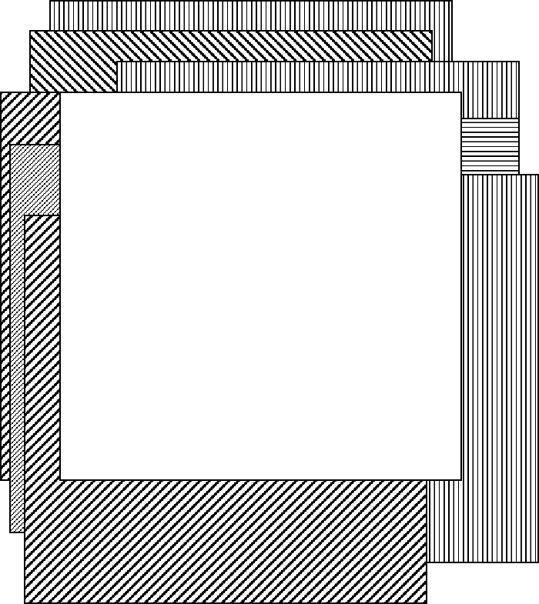

The final thing is that in both papers, after the stabilization process, they remove some parts of the image around the borders, and only keep the central part of the image which is present in most of the images (the white square in the above picture). They believe that since the central part is present in many frames, it is more reliable. That is why their result is so clean and in a squared shape. I also looked at the paper explaining automontaging process and found out that the stabilized images in that paper are also squares with the same size.